X18.18-R
IDEAL FOR LARGE CONSOLIDATED AND PALLETIZED CARGO
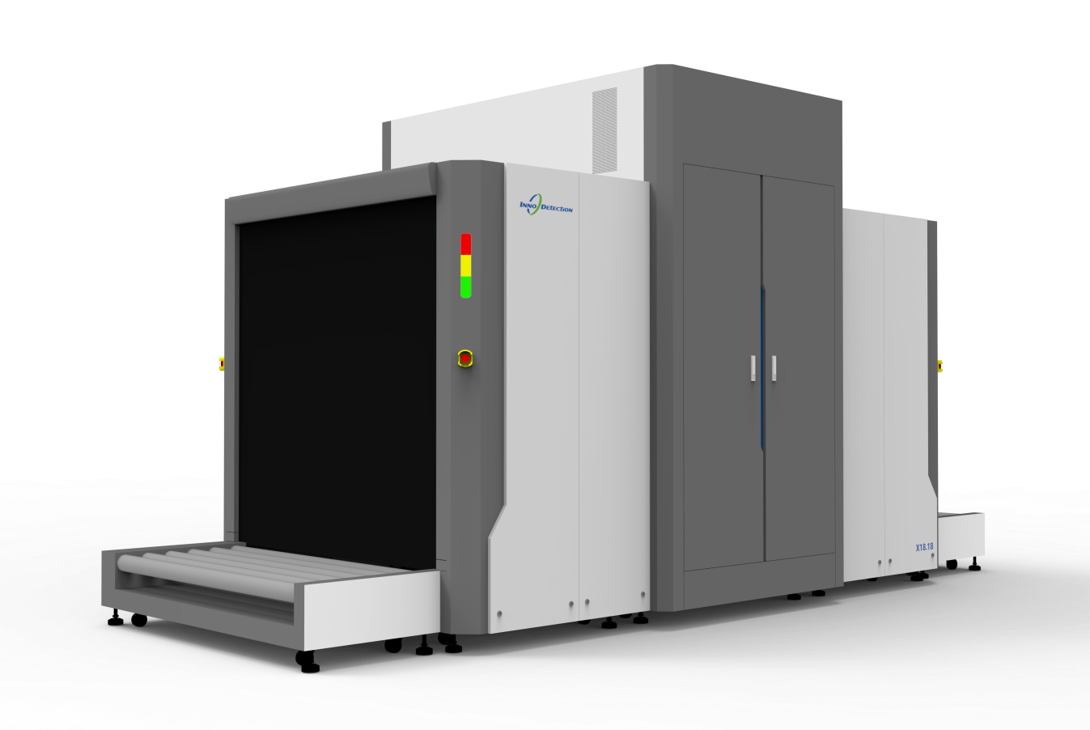
Tunnel dimensions of 180x180cm means the X18.18-R is capable of screening LD3 containers.
The powerful 250kV X-ray generator is capable of penetrating large and dense objects, reducing reinspection times (as consolidated cargo does not usually need to be broken down into smaller items), ensuring high throughput and a fast, efficient inspection process.
The small-pitch roller conveyors ensure a smooth passage for the scanned goods and supports a total load of up to 6600kg (evenly distributed).
The compact footprint minimizes the required floor space, keeping the lifecycle cost low.
The X18.18-R is a powerful tool for the air cargo industry, including forwarders and regulated agents. lt is also suitable for customs purposes and for screening incoming or outgoing goods in critical infrastructure applications.
Core Features
- Universal X-ray system for palletized items
- Beam geometry facilitates the detection of potential threats
- Advanced image processing and threat recognition
- Rugged roller conveyors accepts loads of up to 6600kg evenly distributed
- AI-powered automatic threat recognition

