X18.18D-R
DUAL VIEW SCANNERFOR LARGE CONSOLIDATED AND PALLETIZED GOODS
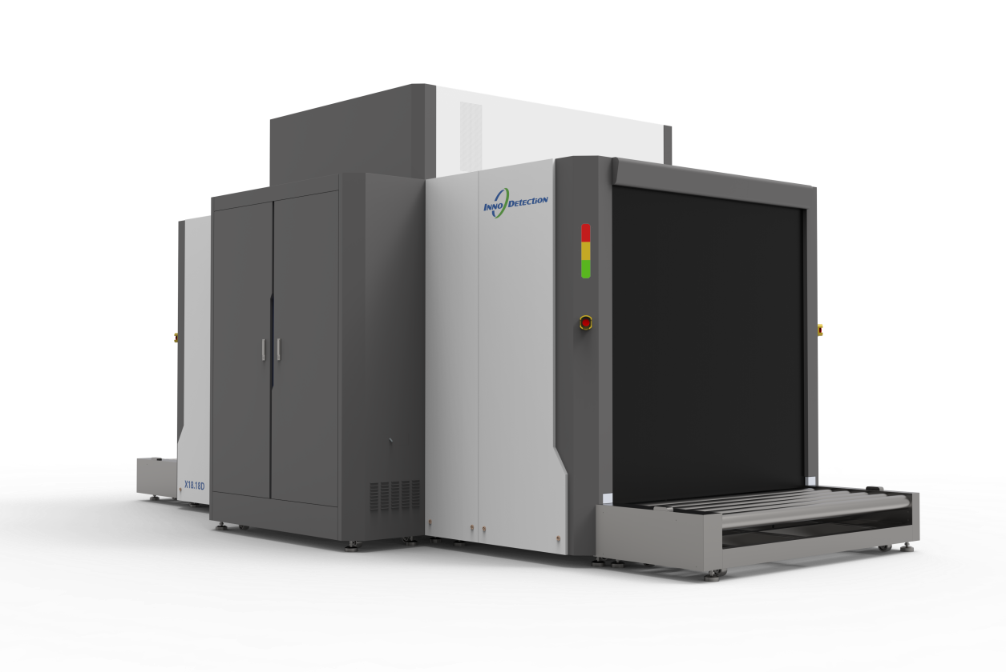
Tunnel dimensions of 180x180cm means the X18.18D is capable of screening LD3 containers.
Based on a dual-view concept, the system provides two sharp independent views of the screened goods and, as a result, it delivers more accurate and reliable image evaluation.
The X18.18D-R is offers excellent threat detection capabilities and outstanding image quality.
Two powerful 250kV X-ray generators are capable of penetrating large and dense objects, reducing reinspection times (as consolidated cargo does not usually need to be broken down into smaller items), ensuring high throughput and a fast, efficient inspection process.
The small-pitch roller conveyors ensure a smooth passage for the scanned goods and supports a total load of up to 6600kg(evenly distributed).
The compact footprint minimizes the required floor space, keeping the lifecycle costs low.
The X18.18D-R is a powerful tool for the air cargo industry, including forwarders and regulated agents. lt is also suitable for customs purposes and for screening received or outgoing goods in critical infrastructure applications.
Core Features
- Reduces threat resolution time
- Advanced image processing and threat recognition
- High-penetration capabilities to avoid diversion into individual packages
- Easy to operate
- AI-powered automatic threat recognition

