X15.15
FAST, COST EFFECTIVE 200kV X-RAY SCANNER FOR LARGE PARCEL AND CARGO SCREENING

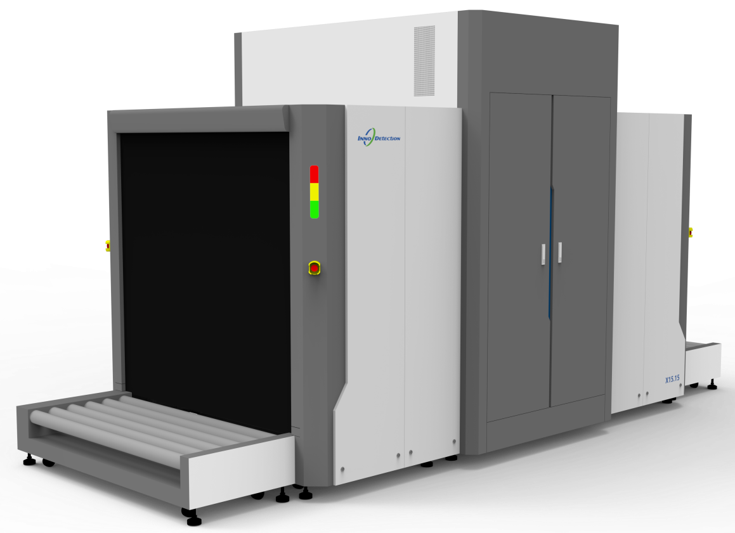
X15.15 system is designed for high throughput screening of oversized, palletized and irregular cargo in freight terminals, customs facilities and logistics centers. Combining a wide tunnel opening with customizable conveyor speed, it enables efficient and reliable inspection without compromising image quality, allowing it to fit a wide range of applications.
X15.15 is fully compatible with automated sorting and logistics systems, supporting synchronized operation for high-volume inspection lines. With built-in AI detection and remote operation capabilities, the system enhances both security accuracy and operational productivity, offering a robust and intelligent solution for modern cargo security needs.
Core Features
- Large 1.5m x 1.5m screening tunnel
- Customizable belt speed 0.2 or 0.3 m/s.
- Seamless integration with automated sorting systems
- Remote image viewing and centralized screening
- AI-powered automatic threat recognition

