X5.3
ECONOMICAL, MOBILE, COMPACT X-RAY SCANNER
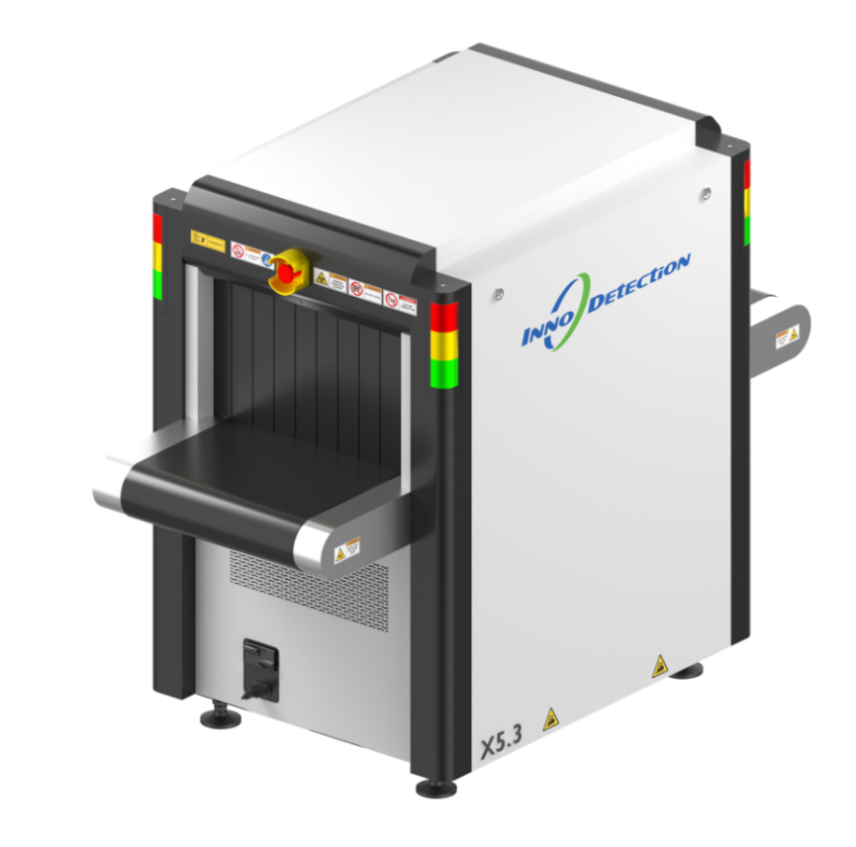
X5.3 is a highly portable, light-weight X-ray scanner designed for fast and reliable screening of mails, parcels, and small bags in mailrooms or at building entrances, schools, courthouses, event venues, stadiums and correctional facilities.
X5.3 is available as a stationary wheeled version featuring vibration shock absorbers and an integrated storage compartment. Its lightweight design allows the system to be transported through standard doorways and into confined spaces, onto vehicles for temporary screening applications or integrated into existing checkpoints without the need for costly infrastructure investments.
The smart image display features give outstanding discrimination between organic and inorganic materials on screen useful for reliable and rapid detection of threat items such as explosive devices, drugs, food or money.
X5.3 has smart system monitoring features such as Power-on Self-Test during start-up and specific diagnosis tools such as Real-time Background Diagnosis and Real-time System Feedback during operation provide instant information about the system's status and ensure easy operation. These features support the operator or technician by providing critical system diagnostics, helping to expedite maintenance and service.

Core Features
- Fast Start-up
- Advanced Image Processing and Threat Recognition
- Highly Portable and Lightweight Design
- Flexible Configuration Options
- AI-powered Automatic Threat Recognition

