X10.10D
HIGH RESOLUTION, DUAL VIEW X-RAY SCANNER FOR LARGER PARCELS, BAGGAGE AND BREAK BULK CARGO
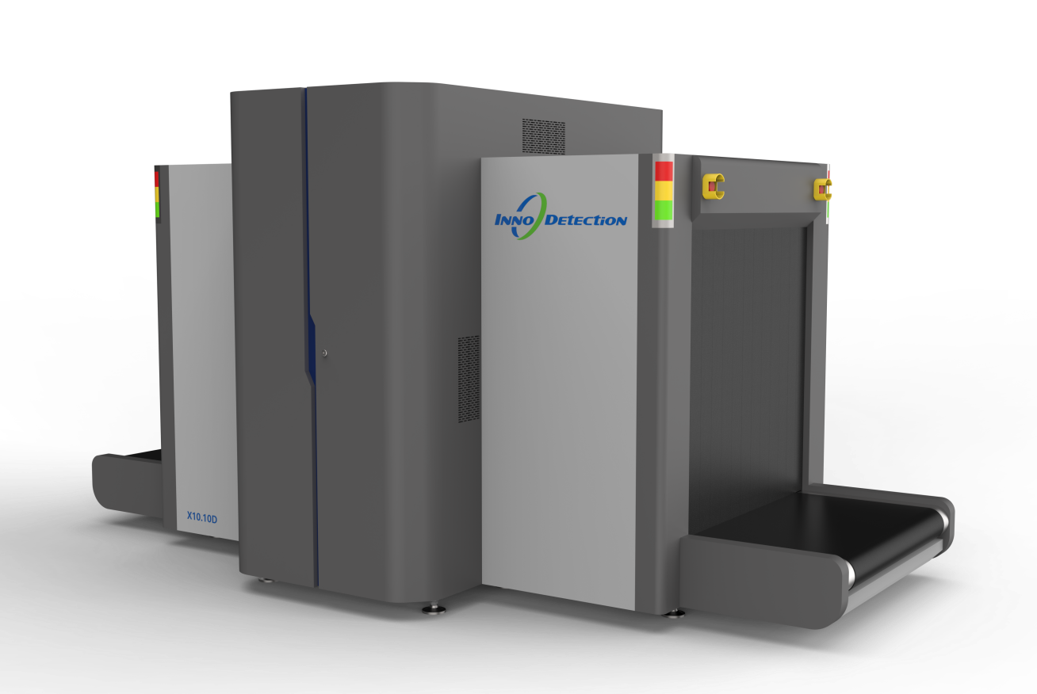
An advanced technology dual view X-ray scanner ideal for ports and borders, logistic hubs and cargo freight centres.
The X10.10D is equipped with two 160kV generators providing a horizontal and vertical view of the screened object. This particular screening method facilitates reliable inspections of tightly packed objects in a single pass, shortening screening times.
Its compact system design provides the highest performance on a small footprint.
Additionally, a conveyor load of 200 kg allows the fast screening of break bulk cargo.
The X10.10D can be easily integrated physically into external material handling systems as well as with intelligent network that allows for Central Image Processing.
The X10.10D is available in two different versions, with a conveyor speed of 0.2m/s or high-speed 0.3m/s model that delivers high throughput for fast turn around. Ideal for high volume air cargo screening applications.

Core Features
- Dual-view technology
- Advanced image processing and threat recognition
- Operator friendly interface
- High-throughout conveyor
- AI-powered automatic threat recognition

