X10.10
COST-EFFECTIVE, MULTI-USAGE X-RAY SCANNER

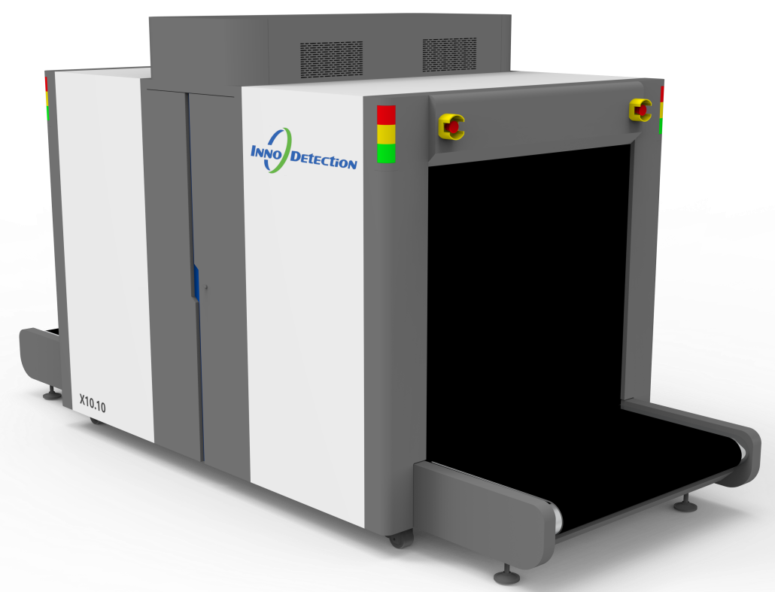
Ideal for quick screening of larger packages, break bulk freight and oversized baggage for fast turnaround and low cost of ownership.
The X10.10 is equipped with a 160kV generator providing adequate penetration capabilities and outstanding image quality.
Its functional system design provides highest performance at a compact footprint. Additionally, a conveyor load of 200kg allows the fast screening of break bulk cargo.
The X10.10 can be easily integrated, physically into external material handling systems as well as with intelligent network that allows for Centralized image processing.
The hardware and software provide best in class image quality for increased operational efficiency. The modular design is optimized for the use of common parts, ensuring easy service and maintenance.

Core Features
- Excellent detection capabilities
- Operator friendly interface
- High-throughout conveyor
- Reliable-efficient screening oriented
- High resolution
- AI-powered automatic threat recognition

