X15.18D-R
HIGH RESOLUTION, DUAL VIEW AIR CARGO X-RAY SCANNER
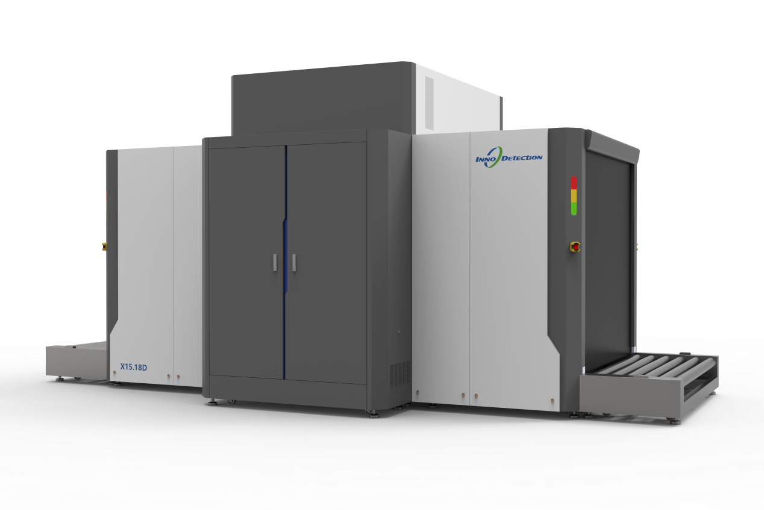

An advanced technology dual view X-ray scanner ideal for screening of air cargo pallets.
The X15.18D-Roller is a capable of scanning objects up to 1.505m (W) x 1.805m (H) .
Due to the compact footprint and large tunnel dimensions, the imaging system is perfectly suited for the inspection of air cargo, freight and palletized goods.
The X15.18D-Roller is equipped with two 200 kV generators, providing a horizontal and a vertical view of the object. This particular screening method facilitates a reliable inspection of even tightly packed objects in a single process. The dual view concept reduces hidden areas and increases the effectiveness of the screening procedure.
Its new, innovative user concept makes it as easy to handle as the single-view system. Even with a second beam direction, this new system remains compact and highly space-saving.
The heavy duty power roller (small pitch design) allows for the screening of heavy objects (up to 2000kg).
Core Features
- Advanced Image Processing and Threat Recognition
- Dual-View Concept Shortens Inspection Times
- Easy to Operate
- AI-Powered Automatic Threat Recognition

