X15.18-R
COST-EFFECTIVE, X-RAY SCANNER FOR AIR CARGO SCREENING
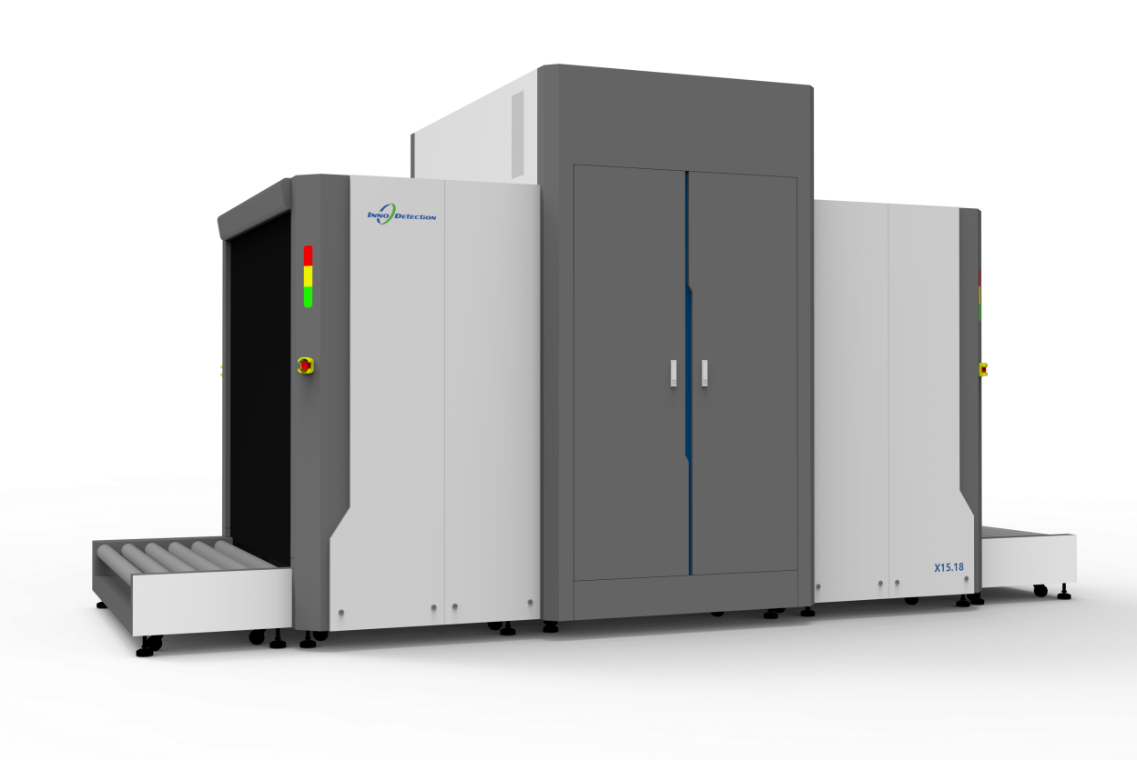

X15.18-R is ideal for screening of palletized cargo in warehouses and logistic centres. It is a state-of-the-art X-ray inspection system for scanning objects up to 1.505m (W) x 1.805m (H) .
Due to the compact footprint and large tunnel dimensions, the imaging system is perfectly suited for the inspection of air cargo, freight and palletized goods.
The X15.18-R is equipped with a single 200 kV generator, providing a vertical view of the object. This screening method facilitates a reliable inspection of even tightly packed objects in a single process.
Its new, innovative user concept makes it as easy to handle as the single-view system.
The heavy duty conveyor (small pitch design) allows the screening of heavy objects (up to 2000kg).
Core Features
- Universal X-ray system for palletized items
- Advanced image processing and threat recognition
- Enhanced operational efficiency
- Easy to operate
- AI-powered automatic threat recognition

