X6.4D
HIGH RESOLUTION, DUAL VIEW X-RAY SCANNER

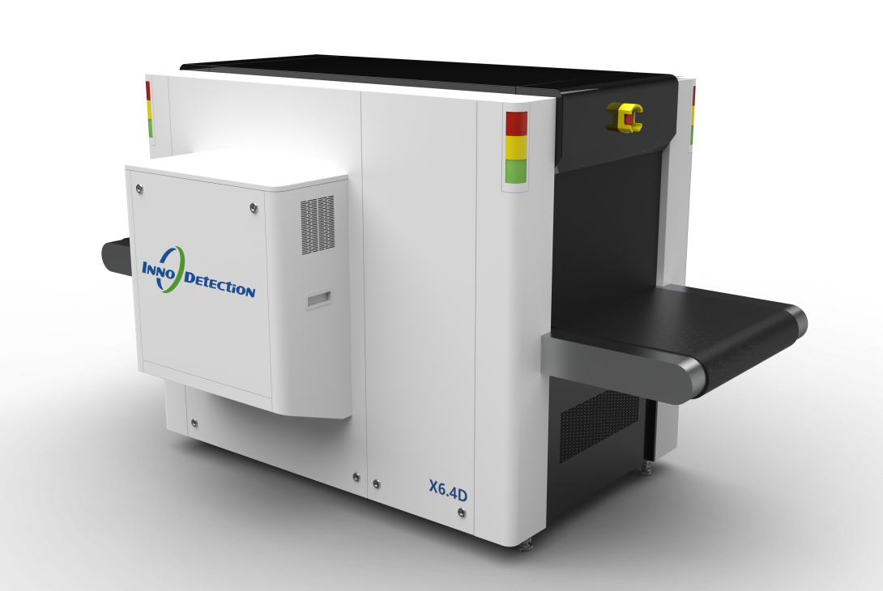
X6.4D is a dual-view X-ray inspection system which integrates cutting-edge technology to deliver efficient and reliable solutions for high-risk environments such as airports, customs, stadiums, hotels, government facilities, and other critical infrastructures.
Its core strength lies in dual-view imaging, which increases the probability of detecting concealed threats in complex, cluttered baggage.
Beyond superior image quality, the system empowers operators through intelligent assistive functions—such as automatic material detection, threat auto-alerts, and configurable display modes—enabling faster and more accurate decision-making. The 0.5m/s conveyor speed option for faster baggage flow is significantly higher than conventional 6040 systems that are typically limited to 0.20 - 0.24m/s, making it ideal for peak-hour screening.
Designed for extensibility and with its compact footprint, X6.4D is built to be integral components of modern security ecosystems, seamlessly connecting with automated tray systems and centralized screening platforms for digitalized workflows and centralized control.
Core Features
- Dual-view detection capability
- Excellent image performance
- Compact design & light weight
- Option of high conveyor speed
- Easy integration & strong compatibility
- Ergonomic and service friendly structural design
- AI-powered automatic threat recognition

