X6.4
AVIATION GRADE QUALITY SCREENING FOR CHECKPOINTS, EVENTS AND BUILDING ENTRANCES
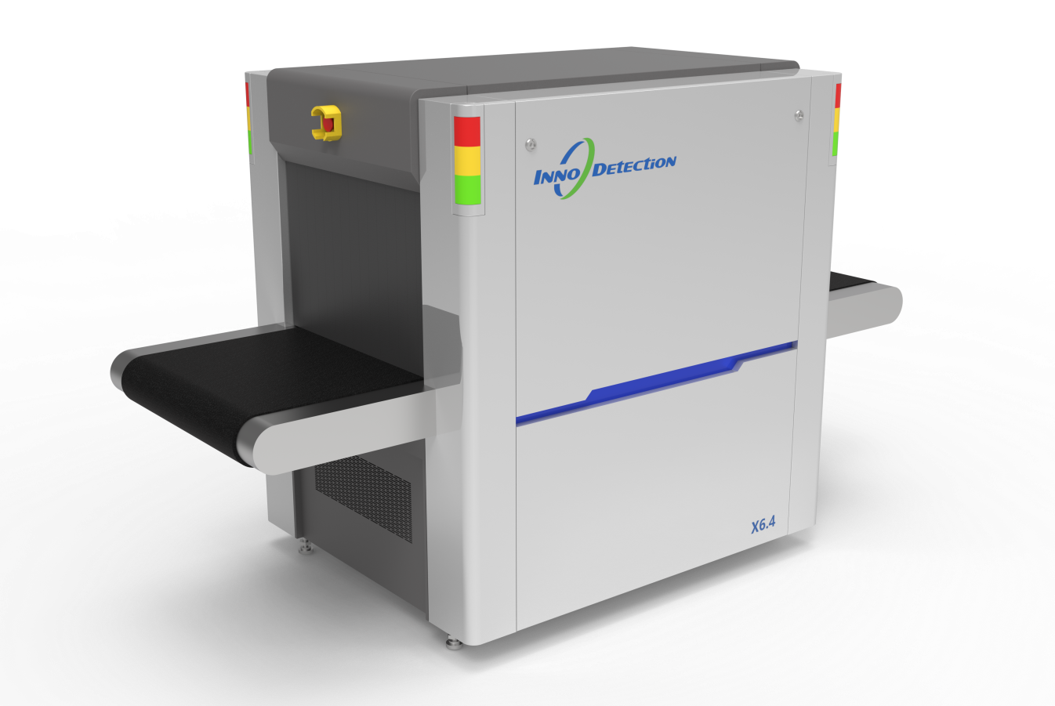
X6.4 is a compact, high-resolution X-ray inspection system designed for reliable screening of bags, parcels, and personal belongings in security-sensitive environments such as public buildings, events, schools, and government facilities.
Equipped with a 160 kV X-ray generator, the system delivers clear, high-contrast images that support accurate identification of prohibited and dangerous items while reducing operator misinterpretation.
Advanced image processing functions-including organic stripping, inorganic stripping and image enhancement-enable effective discrimination between organic and inorganic materials, allowing rapid and reliable threat recognition.
The X6.4 offers flexible conveyor speed options, with a standard 0.2 m/s speed and an optional ultra-high-speed mode of up to 0.5 m/s, ensuring efficient throughput during peak screening periods. Featuring a 620 mm × 420 mm tunnel opening and a compact footprint, the system is built for continuous operation, combining reliability, efficiency, and operator-oriented design to meet modern security screening requirements.
Core Features
- Excellent Image Performance
- High Throughput Conveyor Speed
- Advanced Image Processing Functions
- Easy to Operate
- AI-powered Automatic Threat Recognition

