X7.5D
HIGH RESOLUTION, DUAL VIEW X-RAY SCANNER

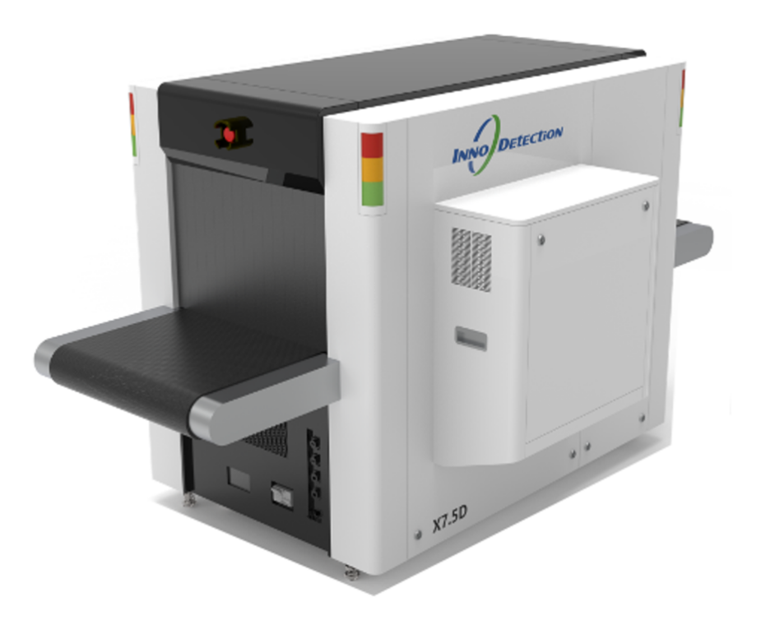
X7.5D is a new generation dual-view X-ray screening equipment that adequately addresses the integrated demands for efficiency, accuracy, and intelligence in high-flow security checkpoints. By employing innovative dual-view scanning to generate multi-perspective inspection data, it significantly overcomes the blind spots inherent in traditional single-view systems, making it particularly suitable for the fast and precise screening of hand luggage, small parcels and baby strollers.
X7.5D goes beyond basic imaging by incorporating advanced detection processing algorithms and threat recognition modules. This progression markedly increases throughput and reduces operational dependency. At the system level, its excellent compatibility allows for easy integration into existing security lines and workstations, supporting massive image storage and remote diagnostics, while enhanced cybersecurity that safeguard critical screening operations from interference. From design to operation, its sustainable screening tools are built to meet present and future security challenges.
Core Features
- Dual-view technology
- Advanced image processing and threat recognition
- Enhanced operational efficiency
- System compatibility and
integration
- Operator- centric design
- AI-powered automatic threat recognition

